Chapter 15, Problem 20.

Using Fig. 15.32, design a problem to help other students better understand the Laplace transform of a simple, periodic waveshape.
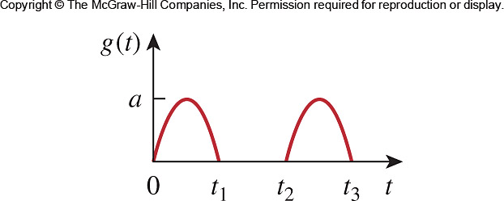

Figure 15.32
For Prob. 15.20.

